**Sing And Dance Academy**

**Introduction**:

I have developed an application in Visual Studio 2022 with the project template as “ASP.NET Core with Angular”

**Technology and Tools used:**

* Visual Studio 2022
* Angular 14
* Json files used a database

**Instructions to run the Application:**

* Unzip the folder “SingAndDanceAcademy”
* Open Visual studio and open the “SingAndDanceAcademy” solution.
* In the Developer Command Prompt (View -> Terminal -> Select Developer Command prompt) and run the command npm install
* Build the solution and debug.

**About the Application**

**The Application contains:**

* Home page with a background picture, a sample logo and some text.
* Albums page with a list of song albums and ability to add, update and delete album
* Concerts page with a list of dance concerts and ability to add, update and delete concert
* Contact Us page with some social media icons.

**Project Structure:**

* ***components***
  + home
  + background
  + album
  + concert
  + contactus
* ***assets***
  + images - for logo
  + jsonFiles - for album and concert list
* ***Controllers***
  + Album
  + Concert
* ***Model***
  + Album
  + Concert

**Screens**

**Home Page:**

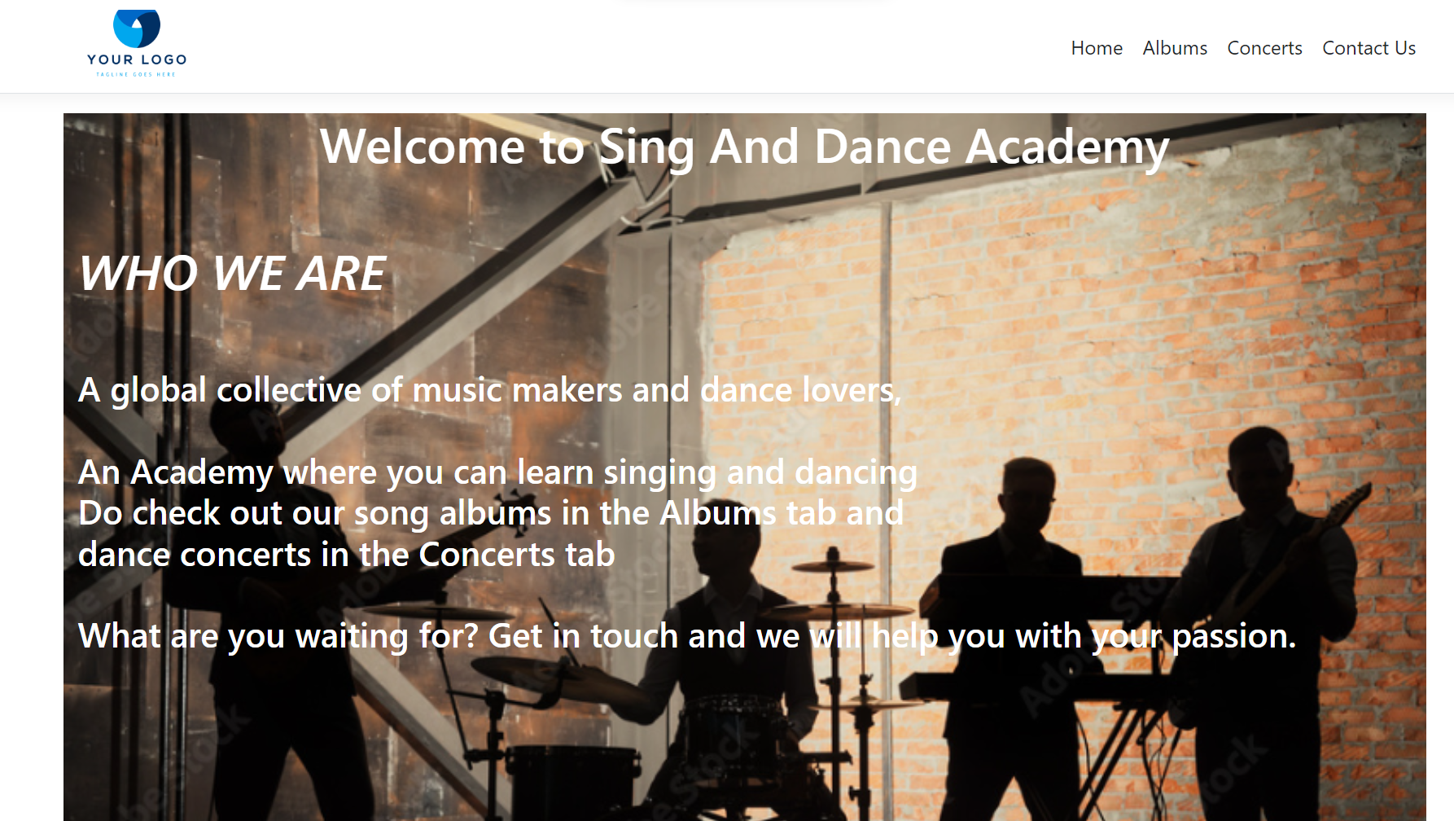

**Albums:**

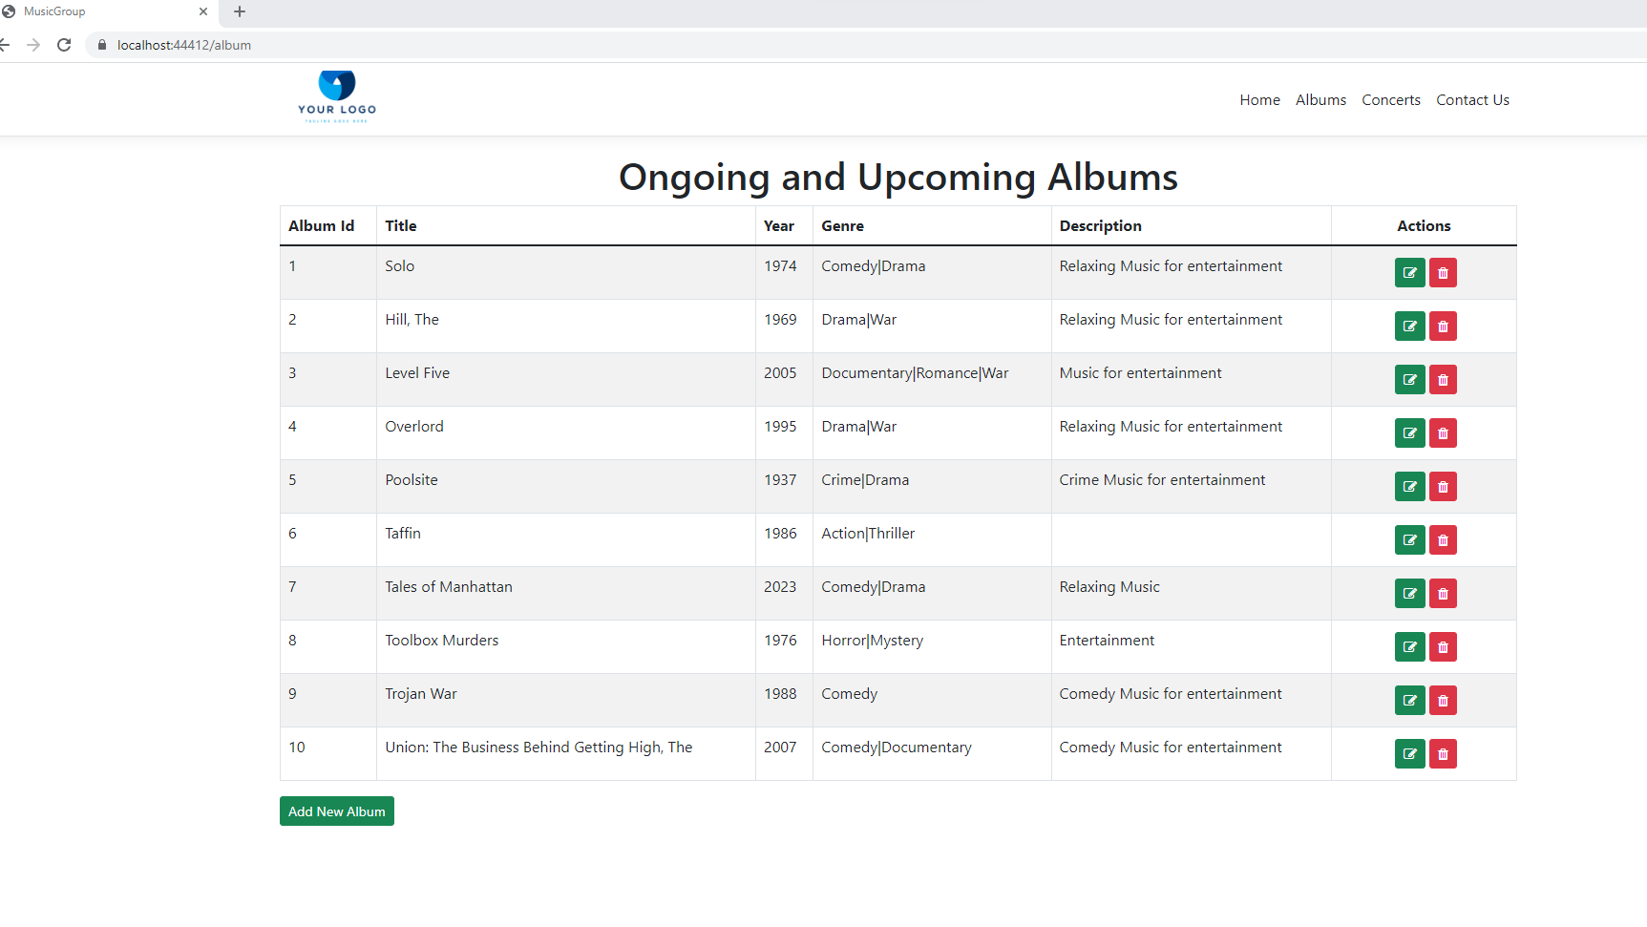

***Album Adding:***

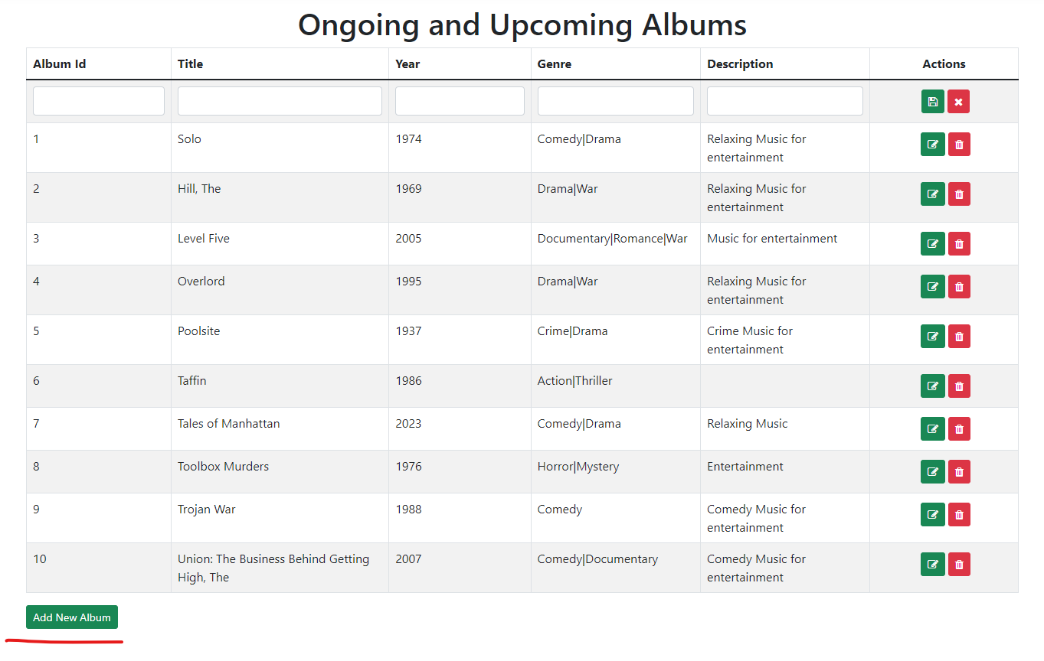

***Album Editing and Deleting :***

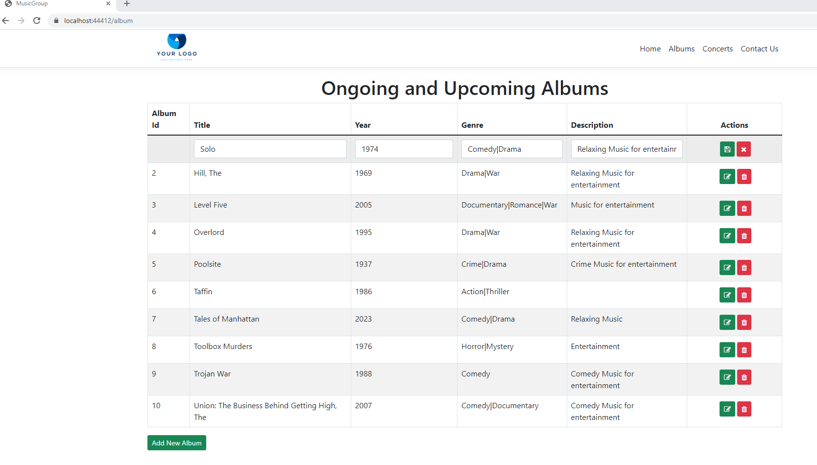

**Concerts**:

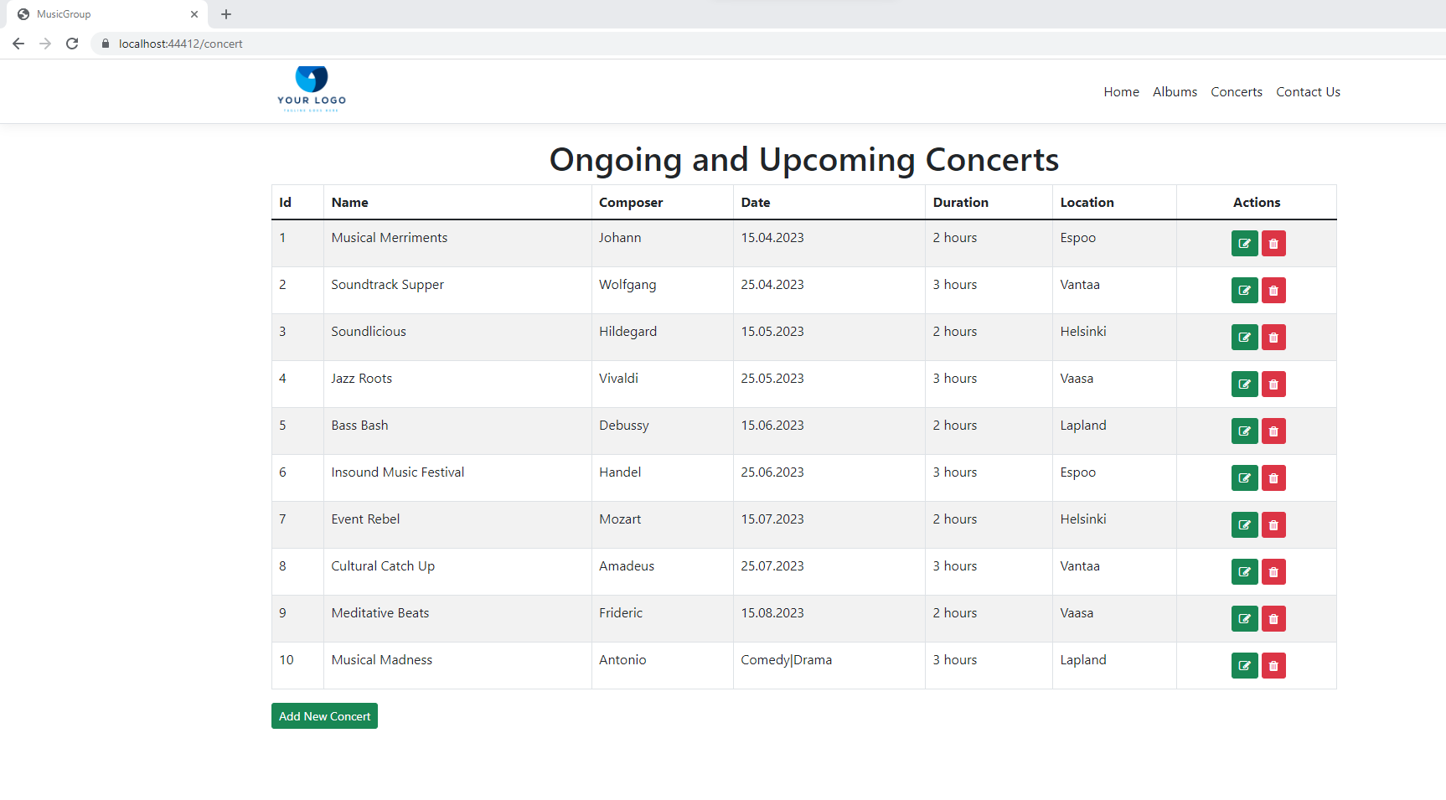

***Adding New Concert:***

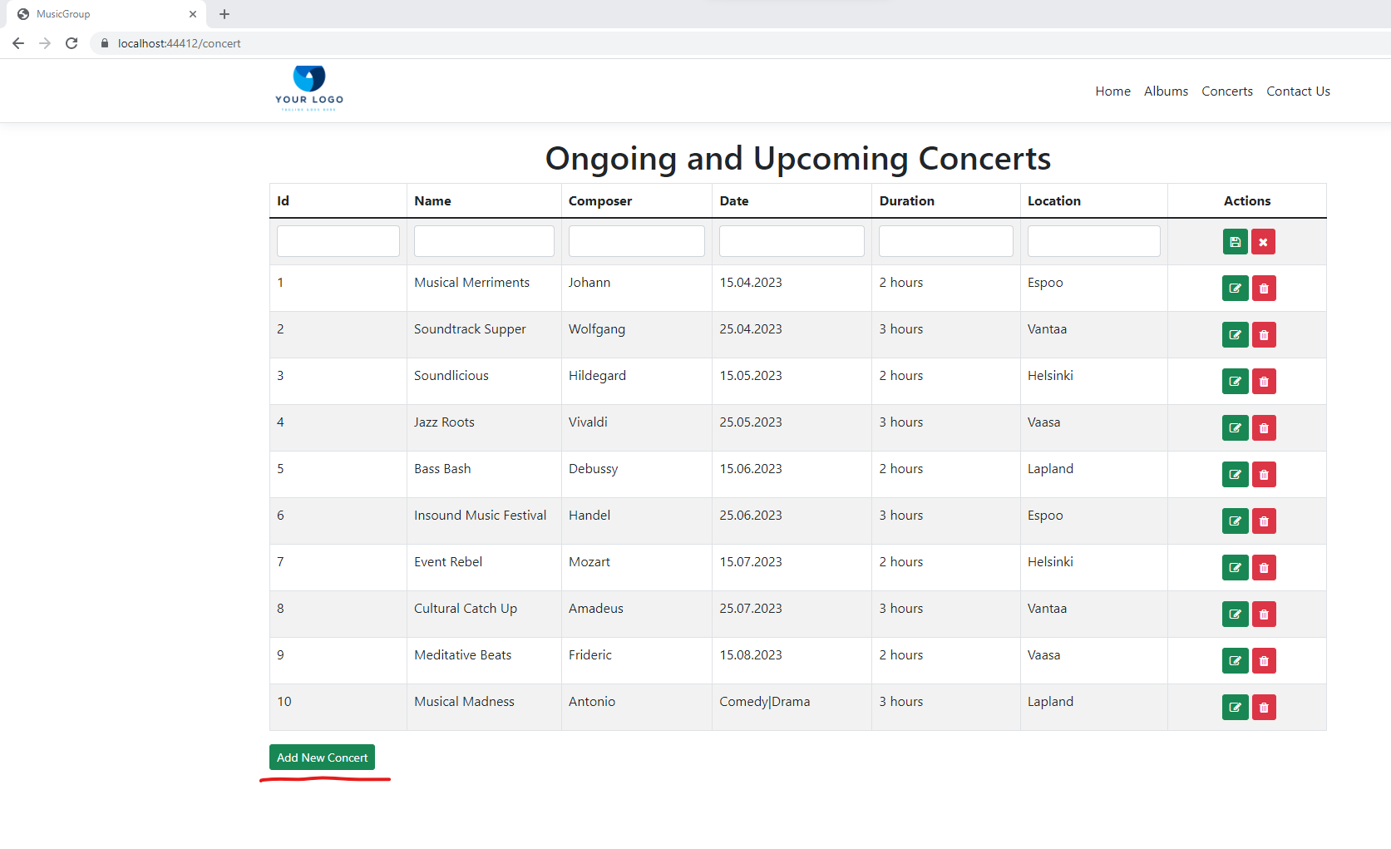

***Editing and Deleting Concert:***

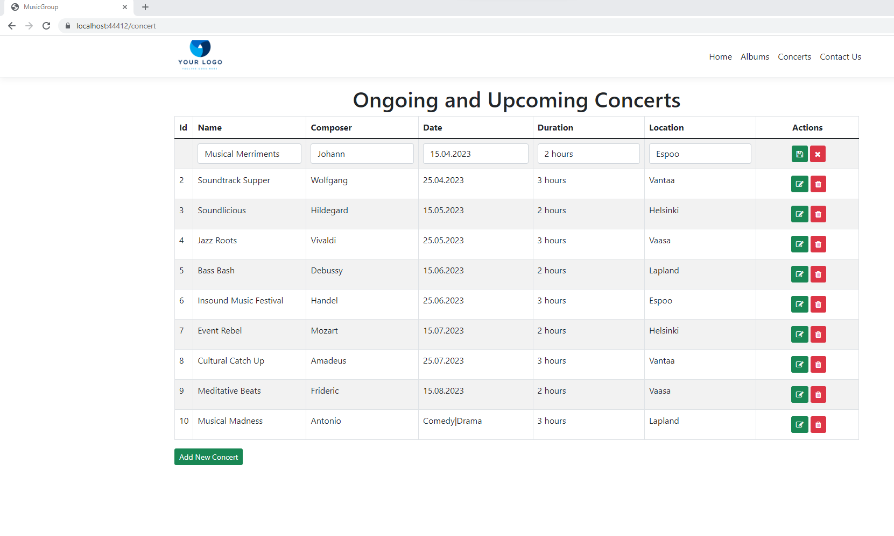

**Contact Us:**

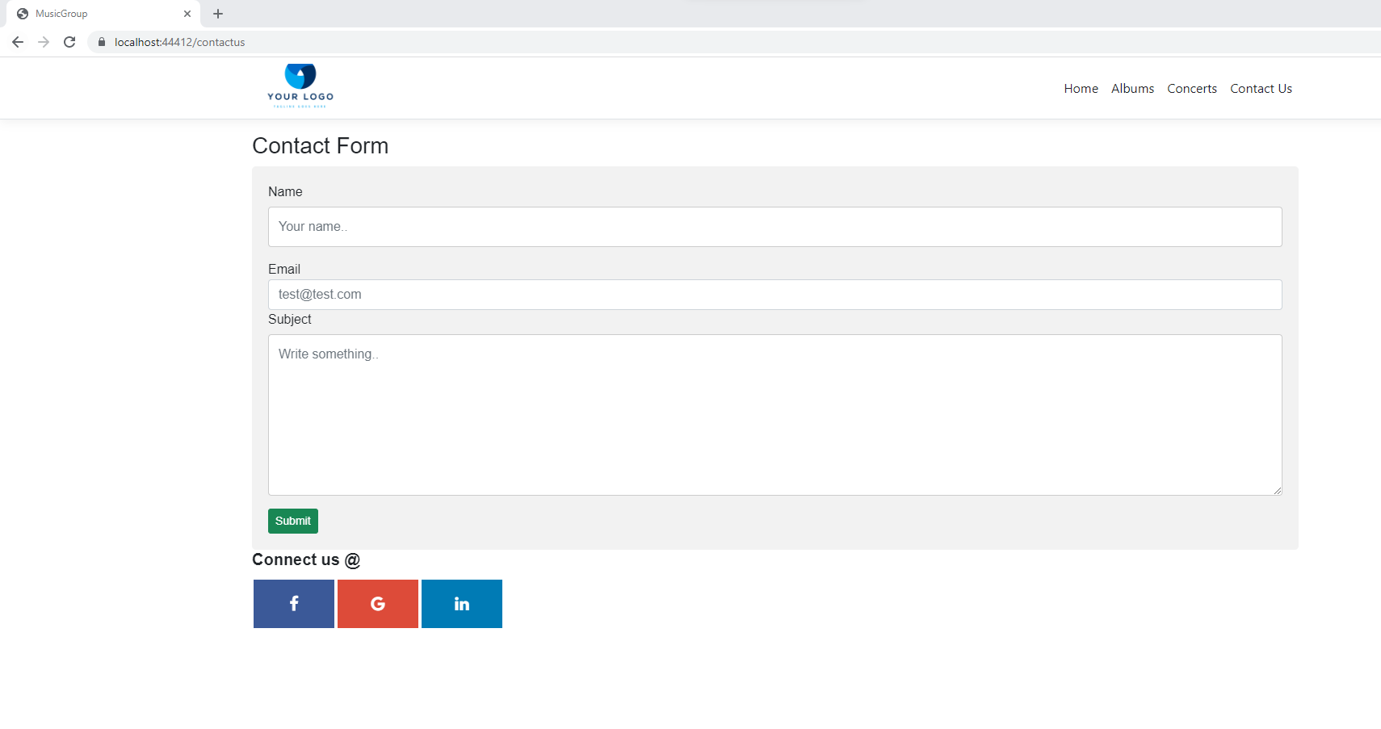

***After Submit click:***

